

Windows Workflow Foundation

Hands-On Lab

Lab Manual
Lab 09 – Modifying Workflow Models at Runtime with Workflow Change in C#

Information in this document, including URL and other Internet Web site references, is subject to change without notice. This document supports a preliminary release of software that may be changed substantially prior to final commercial release, and is the proprietary information of Microsoft Corporation.

This document is for informational purposes only. MICROSOFT MAKES NO WARRANTIES, EITHER EXPRESS OR IMPLIED, AS TO THE INFORMATION IN THIS DOCUMENT.

The entire risk of the use or the results from the use of this document remains with the user. Complying with all applicable copyright laws is the responsibility of the user. Without limiting the rights under copyright, no part of this document may be reproduced, stored in or introduced into a retrieval system, or transmitted in any form or by any means (electronic, mechanical, photocopying, recording, or otherwise), or for any purpose, without the express written permission of Microsoft Corporation.

Microsoft may have patents, patent applications, trademarks, copyrights, or other intellectual property rights covering subject matter in this document. Except as expressly provided in any written license agreement from Microsoft, the furnishing of this document does not give you any license to these patents, trademarks, copyrights, or other intellectual property.

Unless otherwise noted, the example companies, organizations, products, domain names, e-mail addresses, logos, people, places and events depicted herein are fictitious, and no association with any real company, organization, product, domain name, email address, logo, person, place or event is intended or should be inferred.

© 2005 Microsoft Corporation. All rights reserved.

Microsoft, MS-DOS, Windows, Windows NT, Windows Server, Visual C# and Visual Studio are either registered trademarks or trademarks of Microsoft Corporation in the United States and/or other countries.

The names of actual companies and products mentioned herein may be the trademarks of their respective owners.
Contents
Lab 09: Modifying Workflow Models at Runtime with Workflow Change 1
Lab Objective 1
Exercise 1 – WorkflowChange from an Existing Workflow 2
Task 1 – Create a new Workflow Project 2
Task 2 – Create the First Workflow 2
Task 3 – Add a Parameter to the Workflow 8
Task 4 – Create the Second Workflow 9
Task 5 – Add the Program Code 10
Task 6 – Run the Workflow 11
Exercise 2 – WorkflowChange from the Host on an Executing Workflow 13
Task 1 – Modify the Workflow 13
Task 2 – Modify workflow at Runtime 14
Task 4 – Run the Workflow 15
Exercise 3 – Changing Conditions in an IfElse Activity of a Running Workflow 17
Task 1 – Create a new Workflow Project 17
Task 2 – Modify project to run DynamicRulesWorkflow 17
Task 3 – Modify the project to change the conditions of the DynamicRulesWorkflow 20
Task 4 – Run the Code 21
Lab Summary 23

Lab 09: Modifying Workflow Models at Runtime with Workflow Change
Estimated time to complete this lab: 60 minutes. The last two exercises are optional.
The project files for this lab are in the C:\Windows Workflow Foundation\Labs\Lab09 folder.

Lab Objective
The objective of this lab is to demonstrate how to author workflow through code, and apply dynamic changes to a workflow at run-time. After completing this lab, you will be able to:
- Make dynamic changes to the workflow while it is running, from the host and from the workflow.
- Change a declarative condition from the host while the instance is running.

Exercise 1 – WorkflowChange from an Existing Workflow
In this exercise, you will make dynamic changes to a workflow while it is running, from within the workflow itself. The workflow will be able to create activities later in the process based on some external input or learning. You will build this sample from scratch and create a workflow which receives a purchase order request. The workflow creates the PO for amounts less than $1000. For amounts greater than $1000, the workflow dynamically invokes another workflow to approve the purchase order.

Task 1 – Create a new Workflow Project

- Open Microsoft Visual Studio 2005 by going to Start | All Programs | Microsoft Visual Studio 2005 | Microsoft Visual Studio 2005.
- In Visual Studio 2005, select File | New | Project.
- In the New Project dialog box, expand Visual C# | Workflow in the Project types tree on the left.
- Select the template Sequential Workflow Console Application from the Visual Studio installed templates and type the following for the name and location and click OK.

Name: DynamicUpdateInWorkflow.

Location: C:\Windows Workflow Foundation\Labs\Lab09.

Task 2 – Create the First Workflow
You will start by creating the workflow which creates a purchase order and checks to see if the amount supplied is less than or greater than $1000.

- Double click on Workflow1.cs from Solution Explorer if it is not already displayed.
- From the Toolbox, select an IfElse activity and drop it into the area marked “Drop Activities to create a Sequential Workflow”.
- Highlight the branch marked ifElseBranchActivity2, right click on this branch and choose Delete.

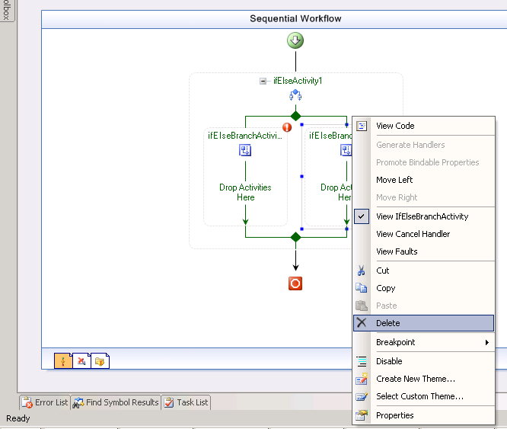

- Right Click select Properties on the ifElseBranchActivity1 branch to bring up the Properties window.
- Select Code Condition from the drop-down list in the Condition box in the Properties window.

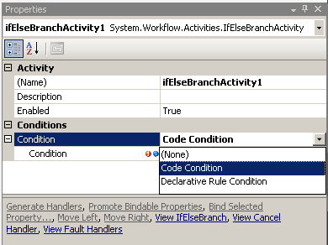

- Click on the plus sign to the left of the Condition box and type CheckAmount in the second Condition property text box.

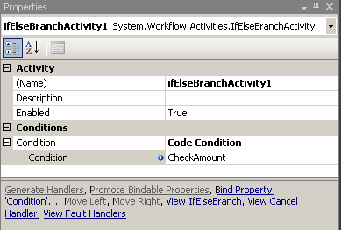

- In the code view Insert the gray highlighted code into the CheckAmount method.

(Snippet: “Lab09 Ex01 Task02 CheckAmount”).
public void CheckAmount(object sender, ConditionalEventArgs e)
{
if (Amount >= 1000)
e.Result = true;
else
e.Result = false;

Console.WriteLine("\tCheckAmount : amount \'{0}\' result \'{1}\'", Amount, e.Result);
}
- Click the Workflow1.cs[Design] tab to return to the Sequential Workflow design view.
- From the Toolbox, select a Code activity and drop it into the area marked “Drop Activities here”, as pictured below.

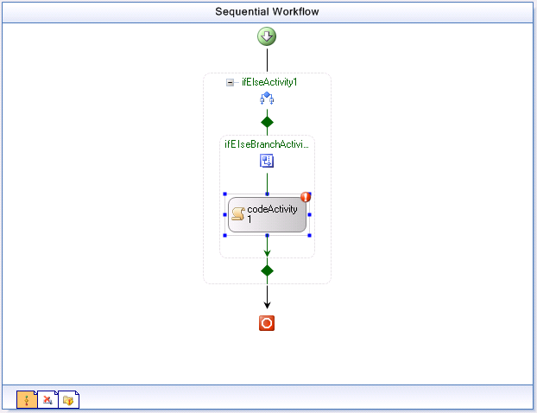

- Right Click select Properties to bring up the Properties window.
- Type AddApproval into the ExecuteCode box.

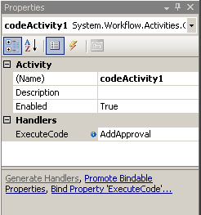

In this Code activity, we will create a new InvokeWorkflow activity that will invoke the second workflow (which we will create in Task 4) and perform a dynamic update to add it to the currently running workflow instance. Add the following code in the AddApproval() method.

(Snippet: "Lab09 Ex01 Task02 AddApproval").
InvokeWorkflowActivity invokeNewStepWorkflow = new InvokeWorkflowActivity();

// use WorkflowChanges class to author dynamic change
WorkflowChanges changes = new WorkflowChanges(this);

// setup to invoke NewStepWorkflow type
Type type = typeof(DynamicUpdateInWorkflow.Workflow2);

invokeNewStepWorkflow.Name = "Workflow2";
invokeNewStepWorkflow.TargetWorkflow = type;

// insert invokeNewStepWorkflow in ifElseApproval
// transient activity collection

CompositeActivity ifElse = changes.TransientWorkflow.Activities["ifElseActivity1"] as CompositeActivity;
CompositeActivity branch1 = ifElse.Activities["ifElseBranchActivity1"] as CompositeActivity;
branch1.Activities.Add(invokeNewStepWorkflow);

// apply transient changes to instance
this.ApplyWorkflowChanges(changes);
Console.WriteLine("\tAdded a new step from within workflow");
- Click the Workflow1.cs[Design] tab to return to the Sequential Workflow design view.
- From the Toolbox, select a Code activity and drop it underneath the ifElse activity right at the bottom of the workflow.

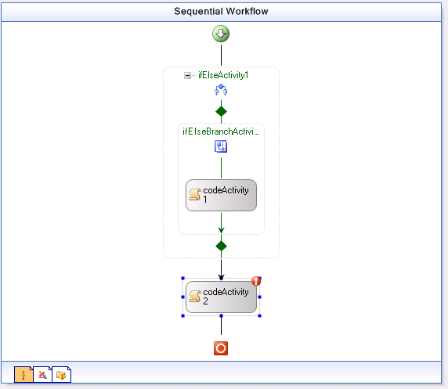

- Click the white exclamation mark in a red circle and select Property 'ExecuteCode' is not set to bring up the Properties window.

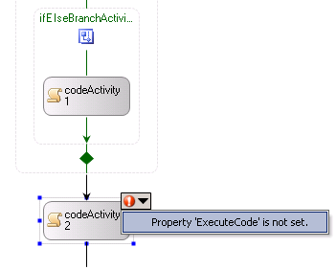

- Type PurchaseOrderCreate into the ExecuteCode box.
- Insert the following code inside the PurchaseOrderCreate method:
Console.WriteLine("\tCreating Purchase Order");

Task 3 – Add a Parameter to the Workflow
- Place the insertion pointer after the PurchaseOrderCreate method and press enter several times to create some space.

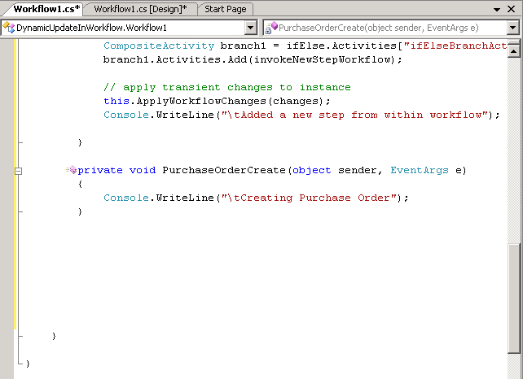

- Right Click on the space you created and select Insert Snippet.

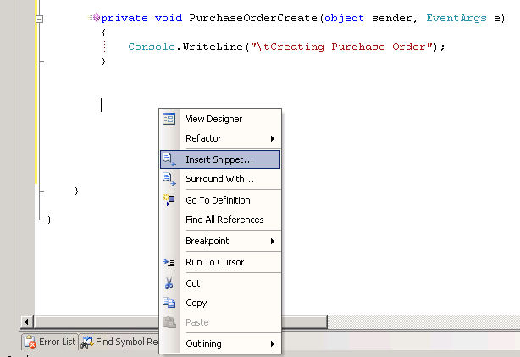
- Select Workflow.

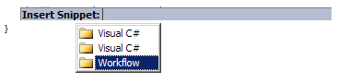
- Select DependencyProperty – Property.

- The text area will be populated with some boilerplate code that you can customize.
- Change MyProperty to Amount, notice that replacements are made from ‘MyProperty’ to ‘Amount”.
- Press Tab, the contents of the return type will be highlighted enter System.Int32 notice that replacements are made from ‘string’ to ‘System.Int32’ then press Enter to finish entering the snippet.

Task 4 – Create the Second Workflow

In this task, you will create the second workflow to handle approvals for purchase orders greater than $1000.
- From Solution Explorer right-click the project DynamicUpdateInWorkflow and select Add | New Item.
- Select Sequential Workflow (code) and accept the default file name Workflow2.cs and click Add.
- From the Toolbox, select a Code activity and drop it in the area marked “Drop Activities to create a Sequential Workflow”.

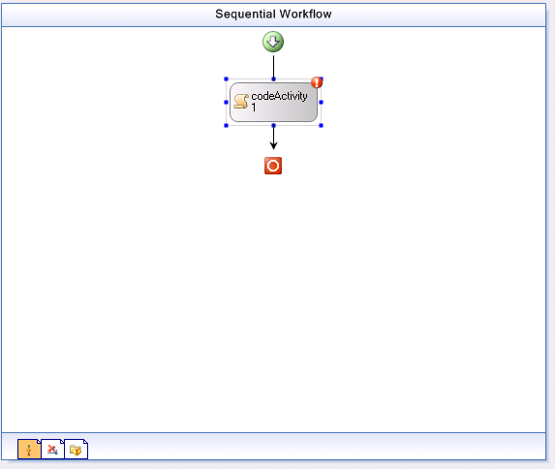

- Double-click on the Code activity and add the following code to handler codeActivity1_ExecuteCode:
Console.WriteLine("\tAdditional Approver Executing");

Task 5 – Add the Program Code

- In the Solution Explorer double-click on Program.cs to open it in the code window.
- Now we need to create a simple console host that will start our main workflow and pass the required parameter to it.
- Replace the following lines:
WorkflowInstance instance = workflowRuntime.CreateWorkflow(typeof(DynamicUpdateInWorkflow.Workflow1));
instance.Start();

with this code.

(Snippet: "Lab09 Ex01 Task05 TestWorkflow").
//start PO approval workflow with purchase less than $1000
Console.WriteLine("Workflow test 1 (purchase less than $1000) :");
int workflow1Amount = 750;
Dictionary<string, object> workflow1NamedValues = new Dictionary<string, object>();
workflow1NamedValues.Add("Amount", workflow1Amount);
WorkflowInstance workflow1Instance = workflowRuntime.CreateWorkflow(typeof(DynamicUpdateInWorkflow.Workflow1), workflow1NamedValues);
workflow1Instance.Start();
waitHandle.WaitOne();

//waiting for the workflow to complete so the console output makes sence
System.Threading.Thread.Sleep(new TimeSpan(0, 0, 0, 10, 0));
Console.Write("\r\n\r\n");

// start PO approval workflow with purchase greater than $1000
Console.WriteLine("Workflow test 2 (purchase greater than $1000) :");
int workflow2Amount = 1200;
Dictionary<string, object> workflow2NamedValues = new Dictionary<string, object>();
workflow2NamedValues.Add("Amount", workflow2Amount);
WorkflowInstance workflow2Instance = workflowRuntime.CreateWorkflow(typeof(DynamicUpdateInWorkflow.Workflow1), workflow2NamedValues);
workflow2Instance.Start();
waitHandle.WaitOne();

//waiting for the workflow to complete so the console output makes sence
System.Threading.Thread.Sleep(new TimeSpan(0,0,0,10,0));
Console.Write("\r\n\r\n");
Console.WriteLine("press ENTER to continue");
Console.ReadLine();

Task 6 – Run the Workflow

- Build the Solution.
- Press CTRL + F5 to run the solution without debugging.
- You should see output resembling the following.

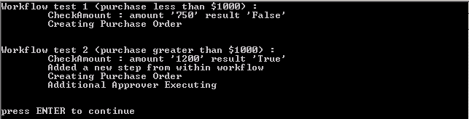

Exercise 2 – WorkflowChange from the Host on an Executing Workflow

Starting with the workflow created in Exercise 1 you will locate a running instance of the workflow and make a change to the workflow from the host program.cs. You will modify ifElseActivity1 to insert an InvokeWorkflow to the host so that all purchase order requests will require approval.

Task 1 – Modify the Workflow

- Double Click on Workflow1 to bring up the designer.
- After the Green Arrow but before ifElseActivity1 drop a DelayActivity, Your Sequential workflow should look like this:

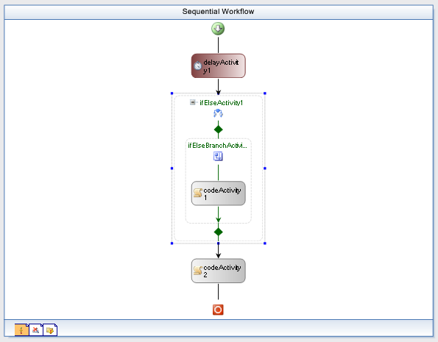

- Right click on delayActivity1, select Properties, and set the TimeOutDuration property to ‘00:00:05’.

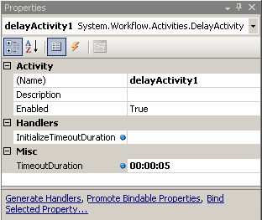

Task 2 – Modify workflow at Runtime
- Double Click on Program.cs to bring it into the code window.
- Add the following using statements.
(Snippet: "Lab09 Ex02 Task02 UsingStatements").
using System.Workflow.ComponentModel;
using System.Workflow.Activities;
- Add the following method to the Program class below the Main method, this code will modify the running workflow .
(Snippet: "Lab09 Ex02 Task02 ModifyWorkflowFromHost").
static void modifyWorkflowFromHost(WorkflowInstance workflowInstance)
{
if (!workflowUpdated)
{
workflowUpdated = true;

Activity workflowInstanceDefinition = workflowInstance.GetWorkflowDefinition();
WorkflowChanges workflowChangesToMake = new WorkflowChanges(workflowInstanceDefinition);

// remove ifelse
Console.WriteLine("\tHost change to always require approval for");
Console.WriteLine("\tInstanceId: " + workflowInstance.InstanceId);

CompositeActivity ifelse = workflowChangesToMake.TransientWorkflow.Activities["ifElse1Activity"] as CompositeActivity;
workflowChangesToMake.TransientWorkflow.Activities.Remove(ifelse);

// setup to invoke NewStepWorkflow type
InvokeWorkflowActivity invokeNewStepWorkflow = new InvokeWorkflowActivity();
invokeNewStepWorkflow.Name = "AddNewStepWorkflow";
invokeNewStepWorkflow.TargetWorkflow = typeof(DynamicUpdateInWorkflow.Workflow2);

// insert approval workflow
workflowChangesToMake.TransientWorkflow.Activities.Insert(1, invokeNewStepWorkflow);

// apply transient changes to instance
workflowInstance.ApplyWorkflowChanges(workflowChangesToMake);
} else {
Console.WriteLine("\tWorkflow has already been updated by the Host");
}
}

Add the following delegates to the Main method after the existing WorkflowTerminated delegate.

(Snippet: "Lab09 Ex02 Task02 WorkflowDelegates").
workflowRuntime.WorkflowIdled +=
delegate(object sender, WorkflowEventArgs e) {
//idling this workflow so we can modify it
e.WorkflowInstance.Suspend("suspending to modify workflow");
modifyWorkflowFromHost(e.WorkflowInstance);
e.WorkflowInstance.Resume();
};
workflowRuntime.WorkflowSuspended +=
delegate(object sender, WorkflowSuspendedEventArgs e) {
string reason = e.Error;
string workflowID = e.WorkflowInstance.InstanceId.ToString();

Console.WriteLine("\tWorkflow \'{0}\' Suspended, reason \'{1}\'", workflowID, reason);
};
workflowRuntime.WorkflowResumed +=
delegate(object sender, WorkflowEventArgs e) {
string workflowID = e.WorkflowInstance.InstanceId.ToString();

Console.WriteLine("\tWorkflow \'{0}\' Resumed", workflowID);
};
- Inside the Program class add a private static member, This will let us know when we have modified the workflow.
static bool workflowUpdated = false;

The above step will now invoke the method modifyWorkflowFromHost when the Workflow1 goes idle. The above method modifyWorkflowFromHost will replace ifElseActivity1 activity by the mandatory approval step in the form of invoking a workflow (defined in Workflow2.cs).

Task 4 – Run the Workflow

- Build the solution.
- Press CTRL + F5 to run the solution without debugging.
- The following output should be displayed:

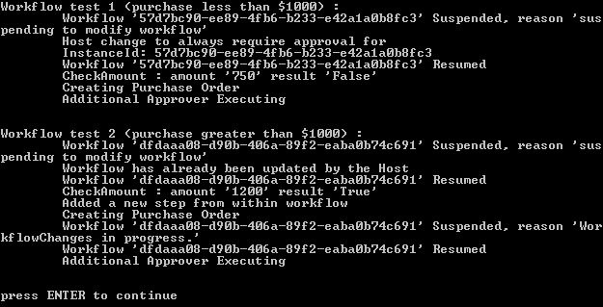

Exercise 3 – Changing Conditions in an IfElse Activity of a Running Workflow

In this exercise, you will locate a running instance of the workflow and make a change to the workflow. The workflow has two branches. Upon receipt of a value less than $10,000 it will execute the branch labeled getManagerApproval, If the value exceeds $10,000 it will execute the branch labeled getVPApproval. You will create the workflow and change the condition dynamically, so that it alters who approves the purchase order.

Task 1 – Create a new Workflow Project

- Open Microsoft Visual Studio 2005 by going to Start | All Programs | Microsoft Visual Studio 2005 | Microsoft Visual Studio 2005.
- In Visual Studio 2005, select File | New | Project.
- In the New Project dialog box, expand Visual C# | Workflow in the Project types tree on the left.
- Select the template Sequential Workflow Console Application from the Visual Studio installed templates and type the following for the name and location and click OK.

Name: DynamicUpdateChangingRules

Location: C:\Windows Workflow Foundation\Labs\Lab09\
- Navigate using Explorer to the directory:

C:\Windows Workflow Foundation\Labs\Lab09\Resources\Exercise3
- Copy All Files to:

C:\Windows Workflow Foundation\Labs\Lab09\DynamicUpdateChangingRules\DynamicUpdateChangingRules
- Right Click on the DynamicUpdateChangingRules project file.
- Select Add | Existing Item…
- Browse to and select the items you copied in step 6.
- Right Click on Workflow1.cs and select Delete.

Task 2 – Modify project to run DynamicRulesWorkflow

- Double click on Program.cs to bring it into the code editor.
- Replace the lines.
WorkflowInstance instance = workflowRuntime.CreateWorkflow(typeof(DynamicUpdateChangingRules.Workflow1));
Instance.Start();

waitHandle.WaitOne();
- With these lines – this will make the DynamicRulesWorkflow execute with the parameters provided.

(Snippet: "Lab09 Ex03 Task02 MainLogic").
// The "Amount" parameter is used to determine which branch of the IfElse should be executed
// a value less than 10,000 will execute branch 1 - Get Manager Approval; any other value will execute branch 2 - Get VP Approval
int workflowAmount = 9000;
Dictionary<string, object> workflowNamedValues = new Dictionary<string, object>();
workflowNamedValues.Add("Amount", workflowAmount);
WorkflowInstance workflowInstance = workflowRuntime.CreateWorkflow(typeof(DynamicUpdateChangingRules.DynamicRulesWorkflow), workflowNamedValues);
workflowInstance.Start();
waitHandle.WaitOne();

Console.Write("\r\n\r\n");
Console.WriteLine("press ENTER to continue");
Console.ReadLine();

- Double Click on DynamicRulesWorkflow to bring it into the designer.
- Right Click on ifElseBranch1 and select Properties to bring up its properties.
- Click the plus beside Condition and Click the elipses beside ConditionName.

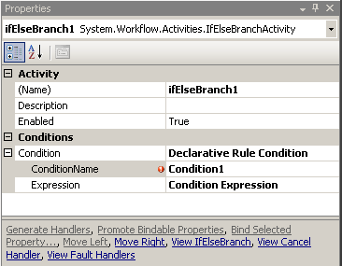

- In the dialog click New… and enter the following rule condition.

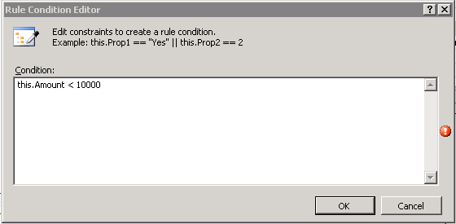

- Click OK.
- Ensure that the name of the condition is Condition1 as pictured below.

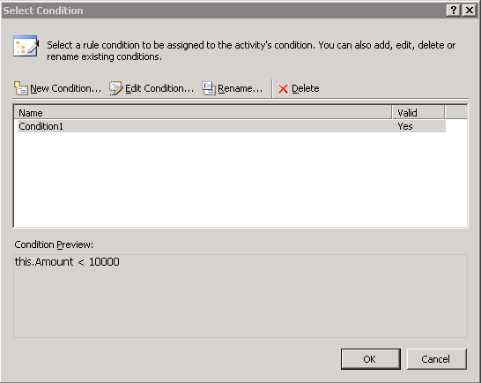

- Press OK.
- Press F5, and you should see the following text outputted to the console.

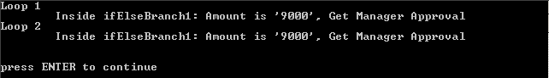

Task 3 – Modify the project to change the conditions of the DynamicRulesWorkflow

- Double click on Program.cs to bring it into the code window
- Add the following using statements at the top of the file.
(Snippet: "Lab09 Ex03 Task03 UsingStatements").
using System.Workflow.ComponentModel;
using System.Workflow.Activities.Rules;
using System.CodeDom;
- Inside the Program class add the following private static member, this will let us know when we have modified the rules.

static bool rulesChanged= false;

- Add the following method changeRulesForWorkflow into the Program class below the Main method.
(Snippet: "Lab09 Ex03 Task03 ChangeRules").
static void changeRulesForWorkflow(WorkflowInstance workflowInstance)
{
if (!rulesChanged) {
rulesChanged = true;

// our new validation amount
Int32 newAmount = 8000;
Console.WriteLine("\tDynamically change approved amount to {0}", newAmount);

// Dynamic update of order rule
WorkflowChanges workflowchanges = new WorkflowChanges(workflowInstance.GetWorkflowDefinition());
CompositeActivity transient = workflowchanges.TransientWorkflow;
RuleDefinitions ruleDefinitions = (RuleDefinitions)transient.GetValue(RuleDefinitions.RuleDefinitionsProperty);
RuleConditionCollection conditions = ruleDefinitions.Conditions;
RuleExpressionCondition condition1 = (RuleExpressionCondition)conditions["Condition1"];
(condition1.Expression as CodeBinaryOperatorExpression).Right = new CodePrimitiveExpression(newAmount);

// Apply our changes to the workflow
workflowInstance.ApplyWorkflowChanges(workflowchanges);

} else {
Console.WriteLine("\tRules for Workflow already changed");
}
}

- Modify the Main method by pasting the following event handlers after the existing WorkflowTerminated handler.
(Snippet: "Lab09 Ex03 Task03 WorkflowDelegates").
workflowRuntime.WorkflowIdled +=
delegate(object sender, WorkflowEventArgs e) {
//idling this workflow so we can modify it
e.WorkflowInstance.Suspend("suspending to modify IfElse1");
changeRulesForWorkflow(e.WorkflowInstance);
e.WorkflowInstance.Resume();
};
workflowRuntime.WorkflowSuspended +=
delegate(object sender, WorkflowSuspendedEventArgs e) {
string reason = e.Error;
string workflowID = e.WorkflowInstance.InstanceId.ToString();

Console.WriteLine("\tWorkflow \'{0}\' Suspended, reason \'{1}\'", workflowID, reason);
};
workflowRuntime.WorkflowResumed +=
delegate(object sender, WorkflowEventArgs e) {
string workflowID = e.WorkflowInstance.InstanceId.ToString();

Console.WriteLine("\tWorkflow \'{0}\' Resumed", workflowID);
};

Task 4 – Run the Code

- Run the solution without debugging by pressing CTRL + F5.
- The following console output should be displayed.

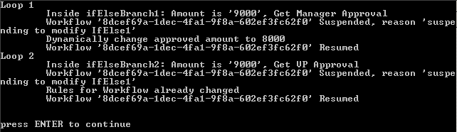

- With an approved amount of 10,000 an order amount of 9000 requires a Manager Approval as the first branch is executed.
- After the host changes the approved amount to 8000, running the same order amount of 9000 should require VP Approval.

Lab Summary
In this lab, you learned how to apply dynamic changes to a workflow at run-time.

In this lab you performed the following exercises.
- Made dynamic changes to a workflow while it is running, from within the workflow itself.
- Made dynamic changes to the workflow while it is running, from the host
- Changing a declarative condition from the host while the instance is running.

